SPH3U0 **Resonance Demos and Note** Date:_________________

**Resonance Definition:**

Every object has a natural frequency or set of natural frequencies at which it will vibrate.

Resonance occurs when energy is transferred to the object by a periodic force which matches one of the

natural frequencies of the object. The energy causes the object to start to vibrate at that frequency.

**Resonance & Standing Waves:**

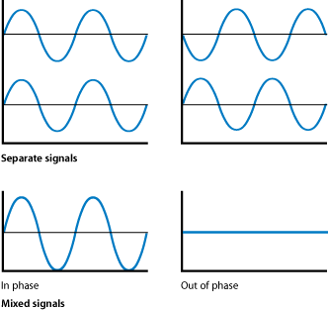

1. What type of interference occurs when two waves are ***in*** phase?
   * Circle: Constructive or Destructive
2. What type of interference occurs when two waves are ***out of*** phase?
   * Circle: Constructive or Destructive

**Demo #1 Pendulums:**

1. 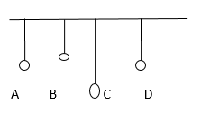What determines frequency (or period) of a pendulum and which pendulum has   
   the same natural frequency as pendulum A?
2. Describe what happens to pendulums B, C, and D when pendulum A is set in motion.
3. Explain how this is an example of the transfer of energy through resonance.

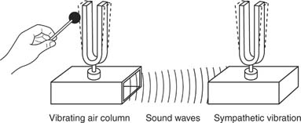**Demo #2 Tuning Forks:**

1. Describe what you observe when the two tuning forks are in tune?
2. Describe what you observe when the two tuning forks are out of tune?
3. Explain how this is an example of the transfer of energy through resonance.

**Other Examples:**

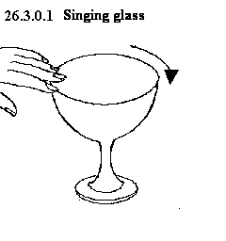

1. Explain how the “Tacoma Narrows” video is an example of resonance.
2. Explain how the MythBusters video is an example of resonance.
3. Provide another example of resonance from your own experience.